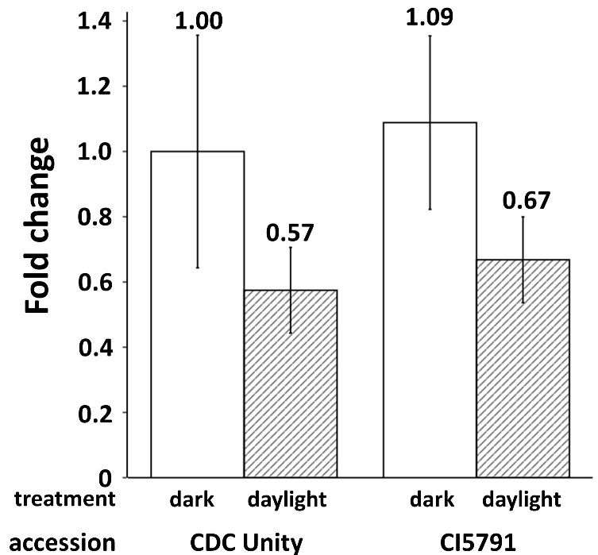
Figure S6. The relative expression (fold change) of SPL3 gene in coleoptile of CDC Unity and CI5791. The ‘dark’ indicated the gene expression in etiolated coleoptile tissue and the ‘daylight’ indicated the gene expression in normal coleoptile tissue under natural light. The expression was normalized using reference gene (actin) and relative to the etiolated coleoptile tissue of CDC Unity (converted to 1).

